Joystick port
___________
( 1 2 3 4 5 )
\ 6 7 8 9 /
# I/O Use \_______/
- --- -------
1 not used
2 > Test joystick 2
3 < Up
4 < Fire button pressed
5 < Left
6 not used
7 > Test joystick 1
8 < Down
9 < Right

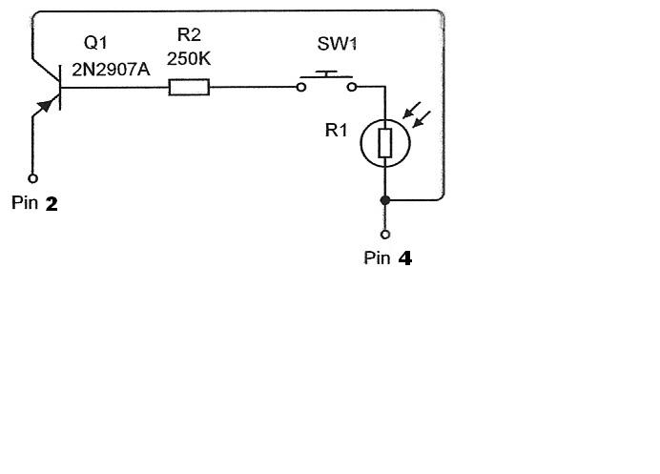
Note: R2 needs to be adjusted for your monitor. Use of a potentiometer is recommended.

